# Notes for assignment

## The problem



## LP relaxation plus dual





## Simple rounding



## Primal dual method



## What do Cplex have APIs for

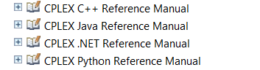

See: <http://pic.dhe.ibm.com/infocenter/cosinfoc/v12r5/topic/ilog.odms.cplex.help/refpythoncplex/html/help.html>

## How do data files look

